Let’s Create angular project

-ng new myapp (you can give any name)

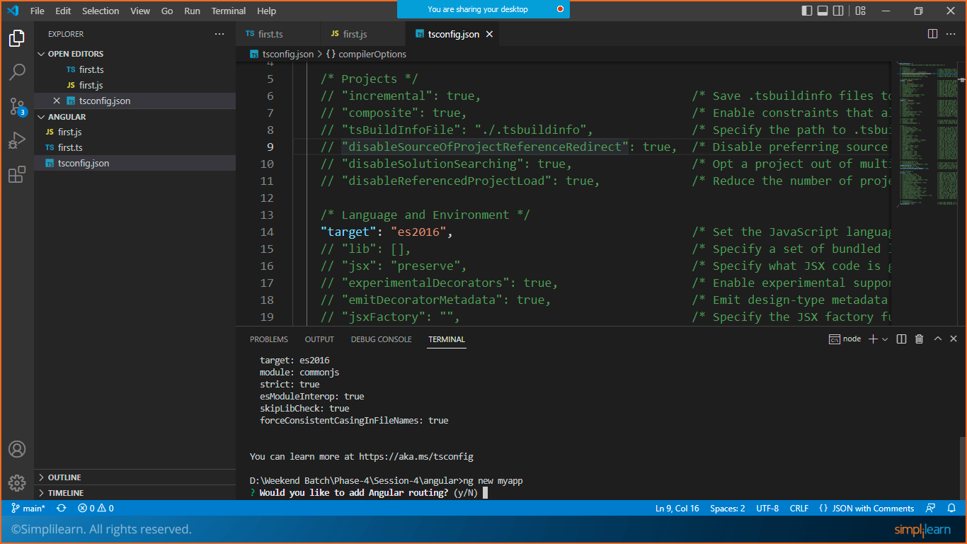

Choose :y

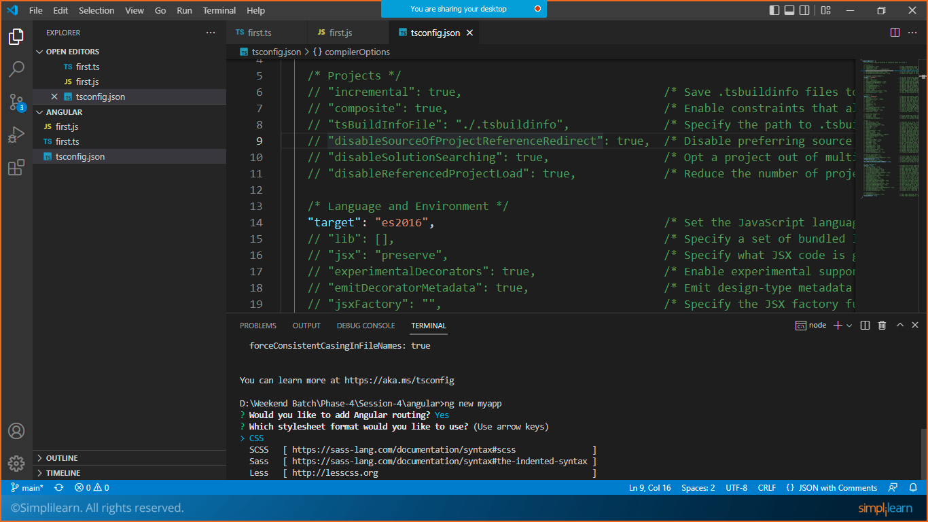

Choose :CSS

Once the app is prepared you need to change the directory from cmd

* cd myapp

to start your angular app

* ng serve

got to the browser and open localhost:4200

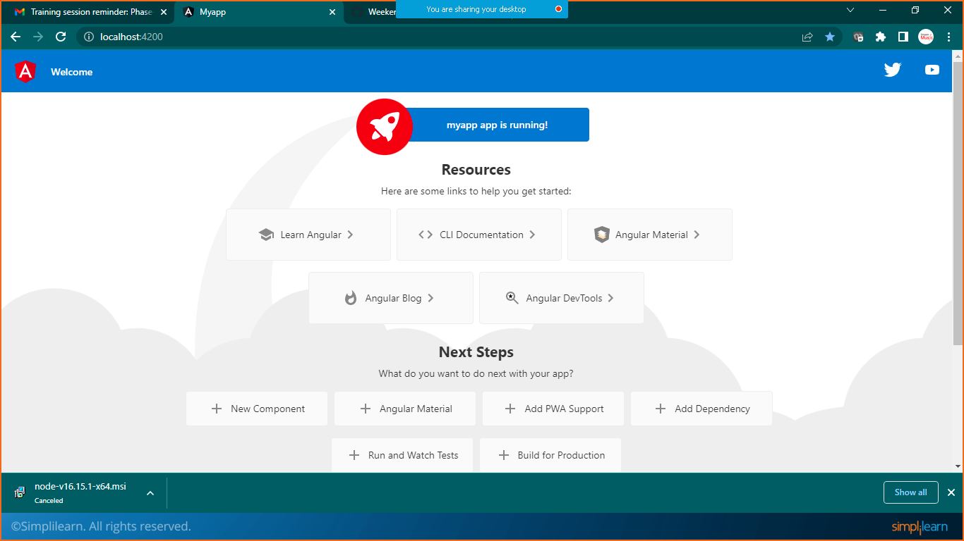

Got to myapp>src>app>**app.component.html**

**Replace your code with existing preloaded code**

<h1>My First Angular App</h1>

Save it and check the output in the browser

Note: browser will automatically refreshed once you save project from visual studio code

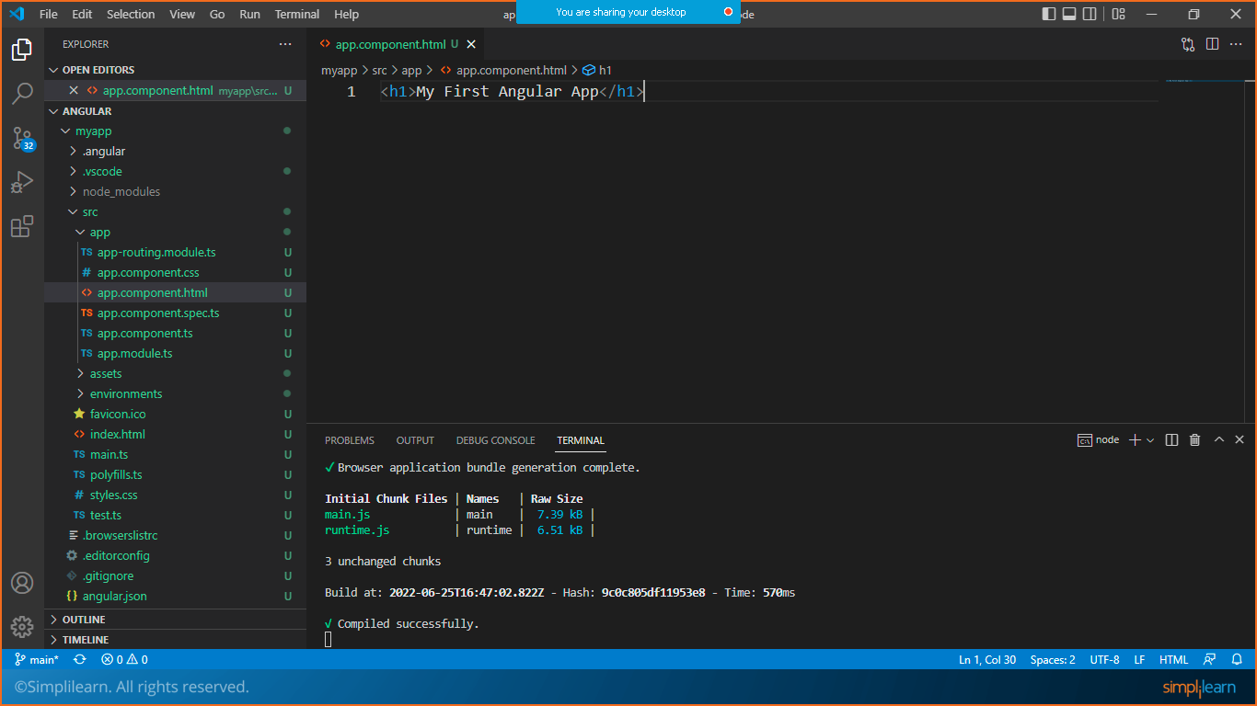

Localhost:4200

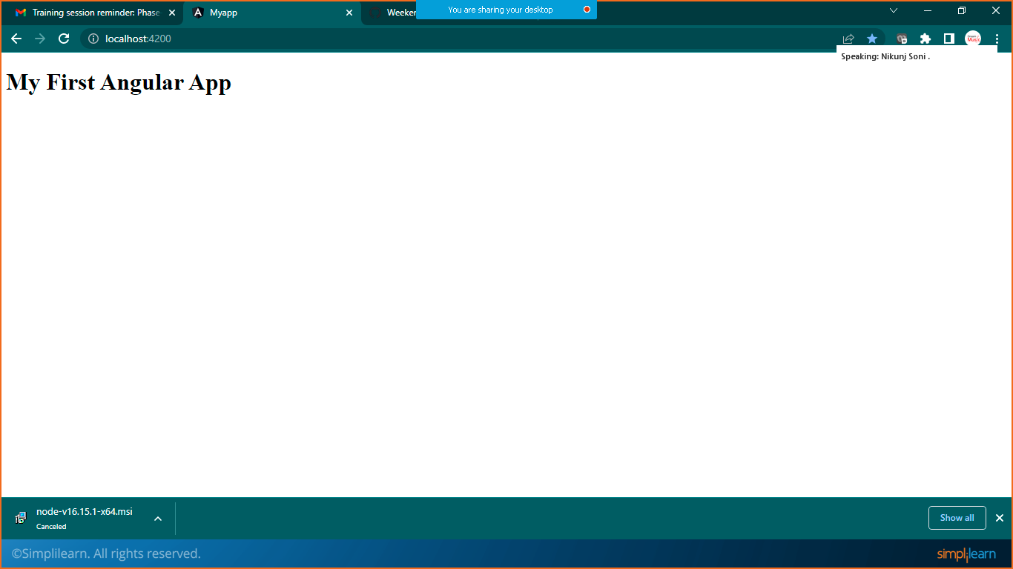

Prepare Angular Components

Open new terminal with cmd and move to the root directory

* cd myapp

or you can change a folder instead

## **PREPARE ANGULAR COMPONENT**

* ng generate component header

or

* ng g c header

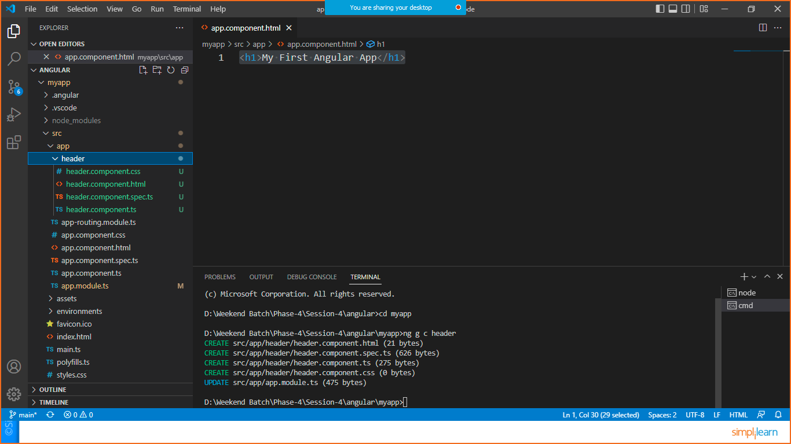

Four files will be prepared automatically with the component

1, header.component.css

2, header.component.html

3,header.component.spec.ts

4,header.component.ts

Every time we will prepare any component this 4 file will be prepared automatically

Now goto header.component.ts file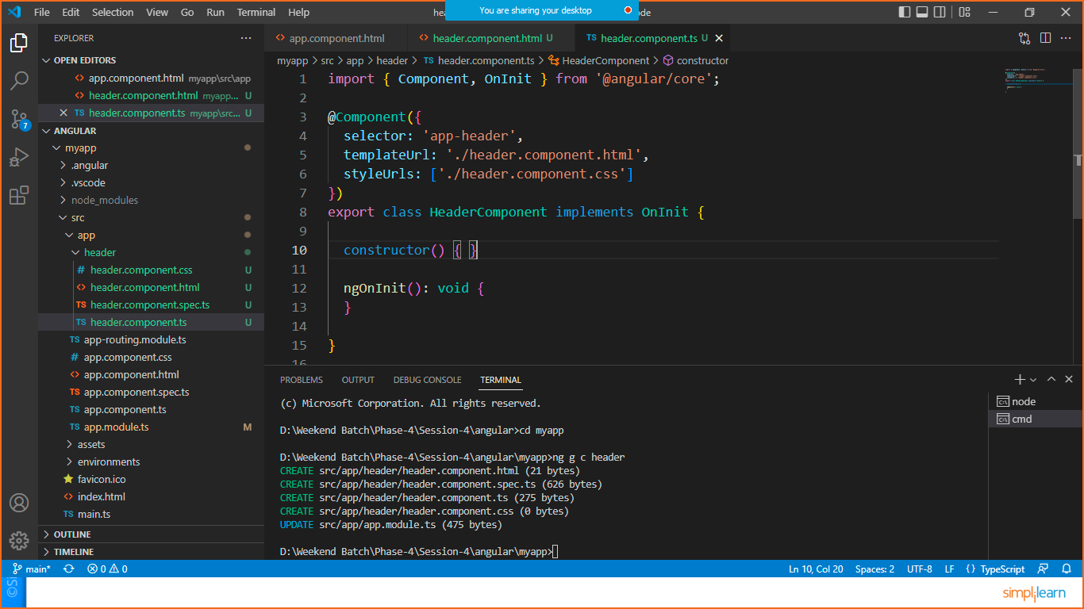

import { Component, OnInit } from '@angular/core';

@Component({

  selector: 'app-header',

  templateUrl: './header.component.html',

  styleUrls: ['./header.component.css']

})

export class HeaderComponent implements OnInit {

  constructor() { }

  ngOnInit(): void {

  }

}

Copy the selector tag as highlighted above

Now go to app.component.html

And paste the copied part in a tag as shown here

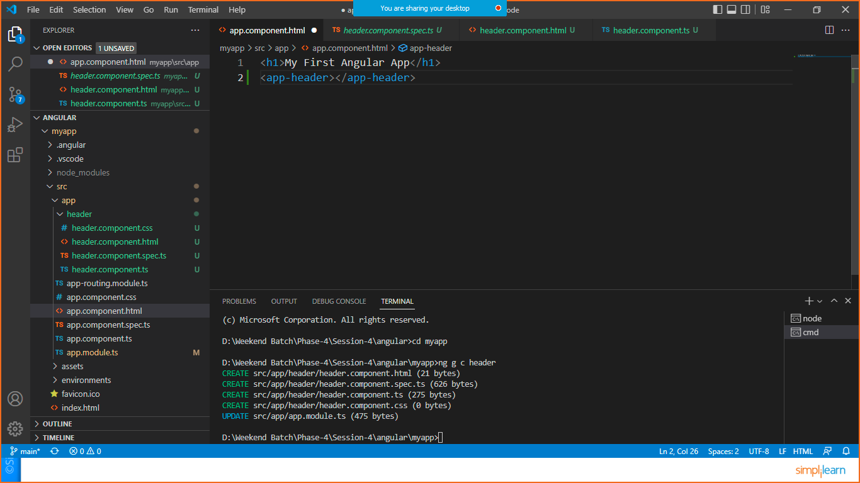

<app-header></app-header>